**COMP 1630**

**PROJECT 1 - ALUMNI DATABASE DESIGN**

Shawn Eapen

Kima Janvelyan

Jae Sung Kim

Cassius Fernandes

**TABLE OF CONTENTS**

Introduction

Process Description

Assumptions

Limitations

Conclusions/Observations

Formal Business Rules

Constraints

Mandatory Attributes

External Views

Normalization

Conceptual View

Sample Data

Query Reports

**Introduction**

In the Database Design/SQL class, our class was assigned a project to design the Cambridge University Alumni database. A narrative was presented, out of which we had to derive business rules, constraints, attributes, and design accordingly. We (group B) worked together at every stage, reaching mutual solutions and conclusions.

**Process description**

First, we identified the business rules and constraints that stemmed directly from the narrative. Then, we asked questions to the professor, from which we derived additional business rules and constraints. We held several group meetings to streamline our conclusions. Afterwards, we identified all the entity relationships, highlighted the M:N relationships and resolved, modelled the Crow’s diagram step-by-step, and normalized to 3NF. Finally, as instructed, we utilized sample data to give examples of reports.

**Assumptions**

Throughout the assignment, we made an assumption that invoicing options will not play a role in the database design process (which usually does in real life situations).

**Limitations**

Since we haven’t had exposure to SQL yet, we took a theoretic approach to design. Once we achieve a better understanding of how SQL works, processes may be improved.

**Conclusion/Observations**

We understand that in the real world there can be many more attributes involved for this type of database. But for simplicity sake we only created what is necessary to establish relations amongst entities, plus a few filler attributes to be able to draw a decent picture. We also assigned surrogate keys to replace composite primary keys. For the normalization process we left the primary keys as they were, then we put the surrogate keys in place because establishing a relation between a bridge and another entity (where this time the bridge is the parent) became too cumbersome with the existing primary key.

**Body of Work**

1. ***A) The formal business rules:***

* One member may be in one or more interest/activity clubs
* One interest/activity club may have zero or more members
* One member may have zero or more interests
* One interest may be held by one or more members
* One event may host zero or more members
* One member may attend zero or more events
* There are 3 states that a member can be in: Active, Holding and Former
* Unpaid members get a grace period of up to 1 year and convert to Holding status
* Historic list contains Former (expired/unpaid beyond grace period) memberships
* Records move from Active to Historic entity entirely
* Invitations can be 3 types: a) General alumni club paid members, b) Gen + 1 other club (has to be paid in both), and c) Gen + more than 1 other club (has to be a paid member in all)
* One member may receive zero or more invitations
* One invitation belongs to one person only, who may or may not attend

***B) Constraints***

* Only paid members can attend events
* All graduates become enrolled in the General Alumni Club
* The first year of the General Alumni Club is free of charge
* After the first year expires, a member has to pay the General Alumni Club fee to be able to join any other clubs
* After the first year expires, a member has to pay the General Alumni Club fee to be able to join any other clubs
* Annual fees must be paid to be a member of a club
* Allow for overlap between General Alumni Club fee due date and Activity/Interest membership expiry date
* Fees are for period of 1 year
* Have to be able to search by Club membership, Interest, Post Code, Country, Graduation Year and Subject studied

***C) Mandatory attributes***

* Primary key for each entity
* First names
* Last names
* Postcodes
* Countries
* Graduation years
* Subject Studied
* Club names
* Interest names
* Membership status
* Start and end dates of current membership
* Start and end dates of previous memberships
* Fee status for memberships
* Fee status for events
* Event names
* Event dates
* Event prices

1. *Identify all M: N relationships and resolve to 1: M relationships (do not go directly to 1:M, if the original business rules implied a M:N, initially)*

The following relationships were identified as Many to Many:

Alumni to Clubs: M:N

Alumni to Interest: M:N

Alumni to Event: M:N

Clubs to Event: M:N

To resolve them, bridge entities were created for each.

For Alumni to Clubs, a Membership Records entity was created, in which composite PKs of Alumni_ID and Club_ID were identified.

For Alumni to Interest, an Interest Records entity was created, in which composite PKs of Alumni_ID and Interest_Name were created.

For Alumni to Event, an Invitation entity was created, in which composite PKs of Alumni_ID and Event_ID were created.

For Clubs to Event, an Event Records entity was created, in which composite PKs of Alumni_ID and Event_ID were created.

1. *Structure your modelling in stages – deal with each functional area separately as an External or End User view (for instance Members and Club Memberships should be treated as such a segment), before bringing them all together in the Conceptual or Designer's view.*

***Alumni to Clubs***



***Clubs to Event***



***Alumni to Interest***



***Alumni to Event***



***Membership to Historic***



1. *Normalization*

***1NF*** *(****Alum_ID, Club_ID****, First_Name, Last_name, Postcode, Country, Subject, Grad_Year, Club_Name, Event_ID, Event_Name, Event_Price, Event_Date, Invitation, Mem_Status, Mem_Start, Mem_End, Mem_Paid, Attendance)*

***Partial Dependencies:***

*Alum_ID -> First_Name, Last_Name, Postcode, Country, Subject, Grad_Year*

*Club_ID -> Club_Name, Event_Name, Event_Price , Event_Date*

***Transitive Dependency:***

*Event_ID -> Event Name, Event_Price, Event_Date*

*Invitation -> Attendance*

***2NF****:*

***Alumni (Alum_ID,*** *First_Name, Last_name, Postcode, Country, Subject, Grad_Year)*

***Club (Club_ID****, Club_Name, Event_ID, Event_Name, Event_Price, Event_Date)*

***Membership (Mem_ID****, Mem_Status, Mem_Start, Mem_End, Mem_Paid, Invitation, Attendance)*

***Transitive Dependency:***

*Event_ID -> Event Name, Event_Price, Event_Date*

*Invitation -> Attendance*

***3NF****:*

***Alumni (Alum_ID,*** *First_Name, Last_name, Postcode, Country, Subject, Grad_Year)*

***Club (Club_ID****, Club_Name)*

***Event (Event_ID****, Event_Name, Event_Price, Event_Date)*

***Membership (Mem_ID****, Mem_Status, Mem_Start, Mem_End, Mem_Paid)*

***Invitation (Inv_ID****, Attendance)*

*We added Interests as a separate Entity in the end in our diagram, with a bridge entity between Alumni and Interests.*

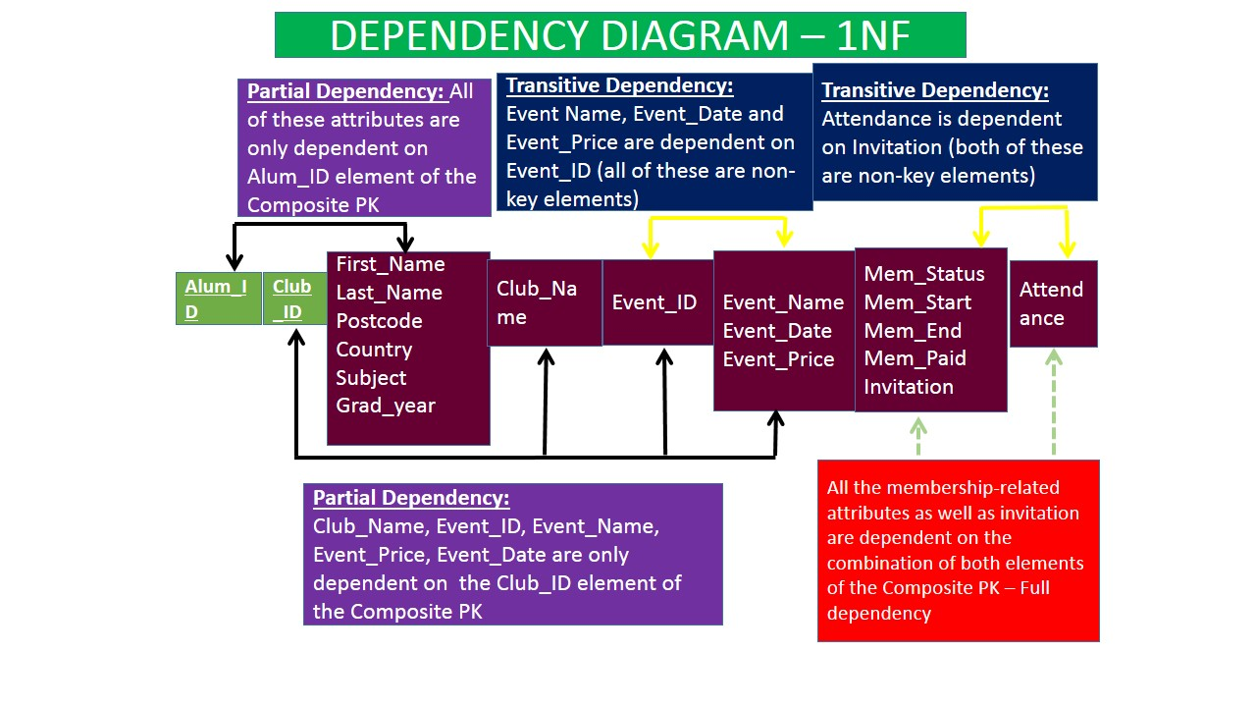

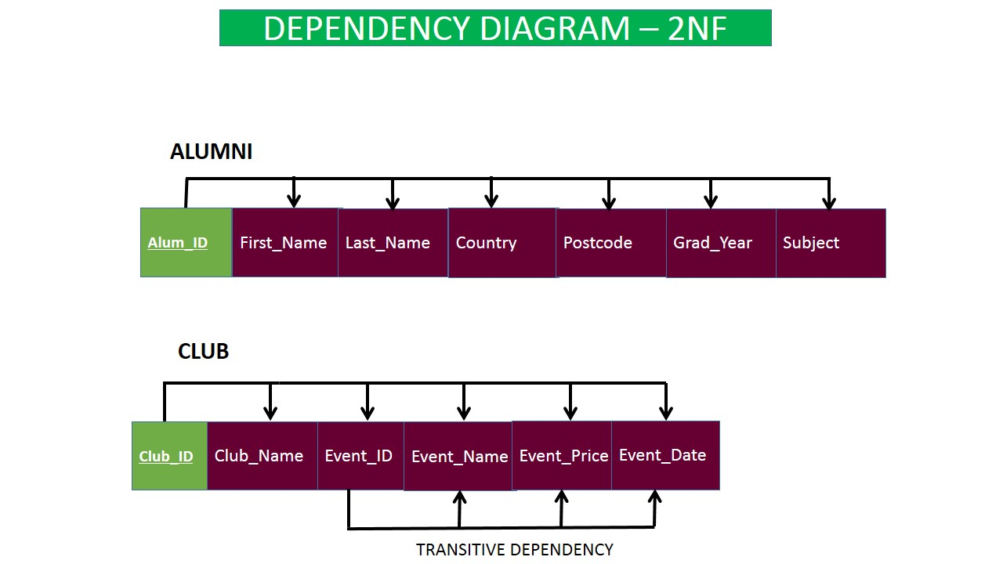

*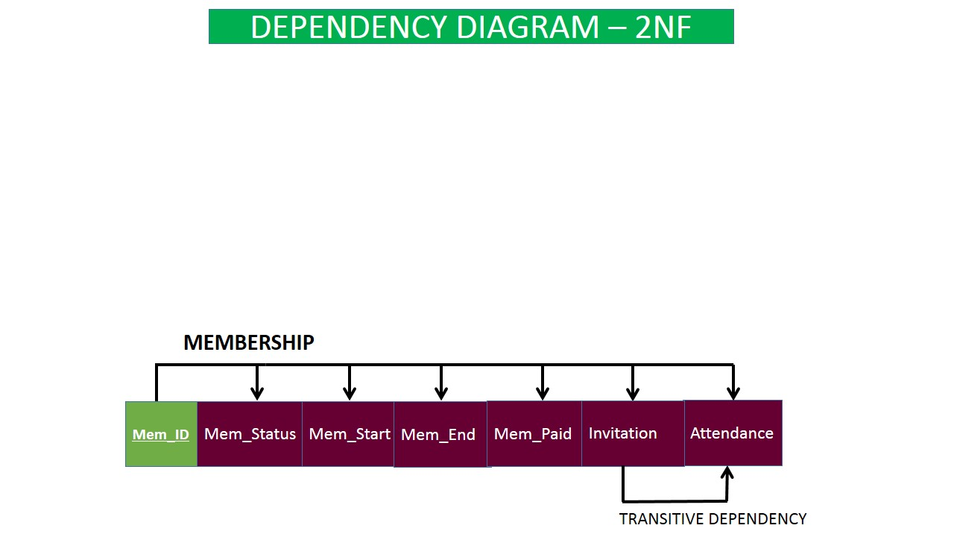*

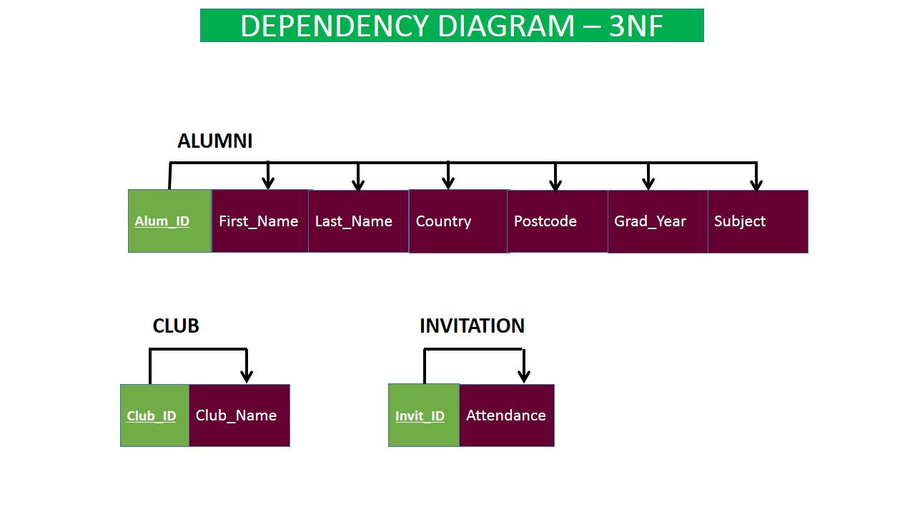

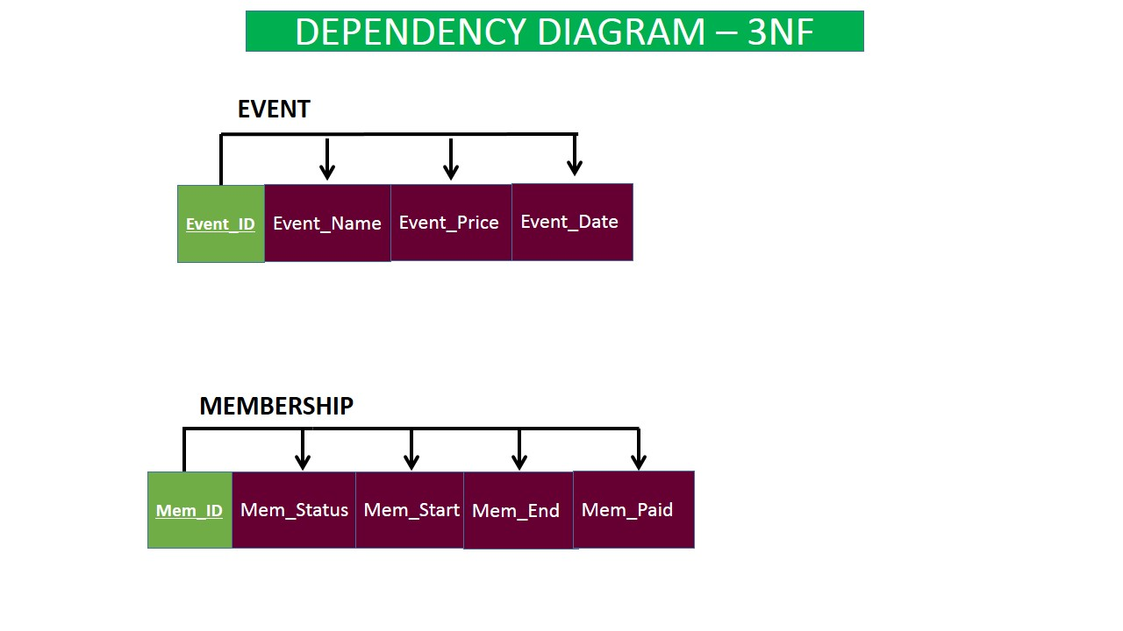

***Conceptual View***



***Sample Data***

1. ALUMNI(ALUM_ID, ALUM_FNAME, ALUM_ADDRESS, ALUM_POSTCODE, ALUM_COUNTRY, ALUM_SUBJECT)

|  |  |  |  |  |  |  |
| --- | --- | --- | --- | --- | --- | --- |
| ALUM_ID | ALUM_FNAME | ALUM_LNAME | ALUM_ADDRESS | ALUM_POSTCODE | ALUM_COUNTRY | ALUM_SUBJECT |
| A00963092 | Noah | Smith | 234 West 8th Ave | V4B 34B | CAN | COMP SCI |
| A00963022 | Liam | Williams | 4920 Broadway | B4N I2N | CAN | LAW |
| A00963132 | Malcolm | Brown | 9448 Silverthorne Court | J4J N34 | CAN | BUSINESS |
| A00963234 | Michael | Rodriguez | 392 Alberta Ave | J3K K4K | CAN | SCIENCE |
| A00964465 | Jayden | Taylor | 4928 Main St | 90210 | USA | ARTS |

1. ALUMNI_INTEREST(ALUM_ID, INT_ID)

|  |  |
| --- | --- |
| ALUM_ID | INT_ID |
| A00963022 | I2 |
| A00963092 | I3 |
| A00963132 | I1 |
| A00963234 | I8 |
| A00964465 | I4 |

1. INTEREST (INT_ID, INT_DESC)

|  |  |
| --- | --- |
| INT_ID | INT_DESC |
| I1 | Badminton |
| I2 | Soccer |
| I3 | Football |
| I4 | Tennis |
| I5 | Chess |
| I6 | Running |
| I7 | Surfing |
| I8 | Skiing |
| I9 | Snowboarding |
| I10 | Golf |

1. INVITATION(INV_ID, MEM_ID, EVENT_ID, INV_PAID, INV_SHOW)

|  |  |  |  |  |
| --- | --- | --- | --- | --- |
| INV_ID | MEM_ID | EVENT_ID | INV_PAID | INV_SHOW |
| I0000001 | M000004 | E00001 | Yes | Yes |
| I0000002 | M000005 | E00001 | Yes | No |
| I0000003 | M000001 | E00002 | Yes | Yes |
| I0000004 | M000002 | E00002 | No | No |
| I0000005 | M000003 | E00002 | Yes | Yes |
| I0000006 | M000001 | E00003 | Yes | Yes |
| I0000007 | M000002 | E00003 | Yes | Yes |
| I0000008 | M000003 | E00003 | Yes | Yes |
| I0000009 | M000004 | E00003 | Yes | Yes |
| I0000010 | M000005 | E00003 | Yes | Yes |
| I0000011 | M000005 | E00004 | Yes | Yes |
| I0000012 | M000004 | E00005 | Yes | Yes |

1. MEMBERSHIP(MEM_ID,ALUM_ID, CLUB_ID, MEM_START, MEM_END, MEM_PAID, MEM_STATUS, MEM_STATUS_ID)

|  |  |  |  |  |  |  |  |
| --- | --- | --- | --- | --- | --- | --- | --- |
| MEM_ID | ALUM_ID | CLUB_ID | MEM_START | MEM_END | MEM_PAID | MEM_STATUS | MEM_STATUS_ID |
| M000001 | A00963022 | C00002 | 02-11-2013 | 02-11-2015 | Yes | Active | MSID00001 |
| M000002 | A00963092 | C00003 | 04-04-2002 | 04-04-2015 | No | Active | MSID00002 |
| M000003 | A00963132 | C00003 | 11-04-2010 | 11-04-2015 | Yes | Active | MSID00003 |
| M000004 | A00963234 | C00006 | 01-09-2015 | 08-09-2016 | No | Active | MSID00004 |
| M000005 | A00964465 | C00007 | 03-29-2012 | 03-29-2015 | Yes | Active | MSID00005 |

1. EVENT(EVENT_ID, EVENT_NAME, EVENT_DATE, EVENT_TIME, EVENT_PLACE,  EVENT_PRICE)

|  |  |  |  |  |  |
| --- | --- | --- | --- | --- | --- |
| EVENT_ID | EVENT_NAME | EVENT_DATE | EVENT_TIME | EVENT_PLACE | EVENT_PRICE |
| E00001 | Annual Athletics Awards Ceremony | 02-20-2015 | 8:00 | Shaw Centre | $55 |
| E00002 | Professional Association Club Conference | 03-12-2015 | 12:00 | Convention Centre | $77 |
| E00003 | Alumni Kick Off | 04-07-2015 | 17:00 | Starbucks at Main Street | $98 |
| E00004 | Basketball Camp | 05-14-2015 | 9:00 | Campus Basketball Gym | $54 |
| E00005 | Asia Students Dragonboat Festival | 06-12-2015 | 17:00 | UBC Rowing Club | $29 |

1. CLUB(CLUB_ID, CLUB_NAME, CLUB_DESC, CLUB_FEE, CLUB_TYPE)

|  |  |  |  |  |
| --- | --- | --- | --- | --- |
| CLUB_ID | CLUB_NAME | CLUB_DESC | CLUB_FEE | CLUB_TYPE |
| C00001 | Chess Club | Tournaments | $220 | Social |
| C00002 | Philosophy Club | Education | $320 | Social |
| C00003 | Law Club | Education | $120 | Social |
| C00004 | Soccer Club | Fitness | $230 | Sport |
| C00005 | Rugby Club | Fitness | $660 | Sport |
| C00006 | Asia Student Club | Social | $230 | Social |
| C00007 | Basketball | Basketball at the BCIT Gym 3 | $102 | Sport |

1. EVENT_REC(EVENT_ID, CLUB_ID)

|  |  |
| --- | --- |
| EVENT_ID | CLUB_ID |
| E00001 | C00004 |
| E00001 | C00005 |
| E00001 | C00007 |
| E00002 | C00002 |
| E00002 | C00003 |
| E00003 | C00001 |
| E00003 | C00002 |
| E00003 | C00003 |
| E00003 | C00004 |
| E00003 | C00005 |
| E00003 | C00006 |
| E00003 | C00007 |
| E00004 | C00007 |
| E00005 | C00006 |

1. HISTORICAL(HIST_ID, ALUM_ID, CLUB_ID, FEE_BALANCE, HIST_MEM_START, HIST_MEM_END, HIST_MEM_ID)

|  |  |  |  |  |  |  |
| --- | --- | --- | --- | --- | --- | --- |
| HIST_ID | ALUM_ID | CLUB_ID | FEE_BALANCE | HIST_MEM_START | HIST_MEM_END | HIST_MEM_ID |
| H0000001 | A00862302 | C00002 | $50 | 04-17-2010 | 04-17-2011 | M000006 |
| H0000002 | A00843392 | C00003 | $102 | 05-05-2002 | 05-05-2006 | M000022 |
| H0000003 | A00862302 | C00003 | $402 | 04-17-2010 | 04-17-2011 | M000041 |
| H0000004 | A00623234 | C00006 | $30 | 01-09-2002 | 08-09-2007 | M000024 |
| H0000005 | A00644465 | C00007 | $32 | 03-29-2012 | 03-29-2014 | M000015 |

Sample Reports

1. What are all the events that the Members have invited to and their attendance record?

Alumni Query

ALUM_ID ALUM_FNAME ALUM_LNAME ATTEND_REC EVENT_NAME

A00963022 Liam Williams Yes Professional Association Club

Conference

A00963022 Liam Williams Yes Alumni Kick Off

A00963092 Noah Smith No Professional Association Club

Conference

A00963092 Noah Smith Yes Alumni Kick Off

A00963132 Malcolm Brown Yes Professional Association Club

Conference

A00963132 Malcolm Brown Yes Alumni Kick Off

A00963234 Michael Rodriguez Yes Annual Athletics Awards Ceremony

A00963234 Michael Rodriguez Yes Alumni Kick Off

A00963234 Michael Rodriguez Yes Asia Students Dragonboat Festival

A00964465 Jayden Taylor No Annual Athletics Awards Ceremony

A00964465 Jayden Taylor Yes Alumni Kick Off

A00964465 Jayden Taylor Yes Basketball Camp

1. Who Attended the Professional Club Conference event?

| **ALUMNI Query** | | | | |
| --- | --- | --- | --- | --- |
| **ALUM_ID** | **ALUM_FNAME** | **ALUM_LNAME** | **ATTEND_REC** | **EVENT_NAME** |
| A00963022 | Liam | Williams | Yes | Professional Association Club Conference |
| A00963132 | Malcolm | Brown | Yes | Professional Association Club Conference |

Note: Noah Smith paid for the event but did not attend.

1. What Interests did people who Joined the Law Club have?

|  |  |  |  |  |
| --- | --- | --- | --- | --- |
| **INT_ID** | **INT_DESC** | **CLUB_NAME** | **CLUB_TYPE** | **CLUB_ID** |
| I1 | Badminton | Law Club | Social | C00003 |
| I3 | Football | Law Club | Social | C00003 |

Badminton and Football